## horizontal line

Transfer Learning

21.04.2025

**─**

[Transfer learning](https://colab.research.google.com/drive/1U5Uww9kxsDXdUZqi4i2TMneYsp07PqC7)

[Keras API model](https://colab.research.google.com/drive/1LHkNLDwG32beqaHc3NOAUlj3YXigZW3r)

# Transfer learning

A research problem in ML that focuses on storing knowledge gained while solving one problem and applying it to a different but related problem.

Let’s train our model on VGG16 MODEL by two ways : 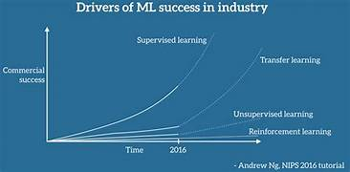

1. Feature extraction
2. Fine tuning

VGG16 also trained on ImageNET.

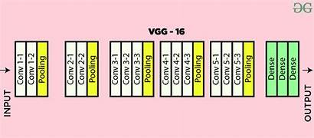

## Feature Extraction

Used when a somewhat similar image is provided.

Here the conv_base is not trained only on the FC layers because the features are similar, just the linear combination and its classification is different. Because we want the same trained weights of VGG.

## Fine Tuning

Used when a totally different (from imagenet) image is provided.

Here the conv_base last layers are trained not all layers and the FC also. This is done because the primitive features are extracted but the complex ones to make from them are different.

# Keras Functional Model

ANN and CNN usually make a Sequential model , where only one type of input , one type of output and linear topology of hidden layers.

Non Linear models do have multiple input , multiple output (i.e. in branching).

E.g. predict product price using product metadata , its description and image.

